Exercise 3 answer

step1 - add border-router.c as sky mote from contiki/examples/ipv6/rpl-border-router folder

step 2 – add 3 sky-websense.c as sky mote from contiki/examples/ipv6/sky-websense folder

step3 - open terminal and cd/contiki/tools

step4 – $ make tunslip.6

step 5- right click on mote 1 and select serial socket (server)

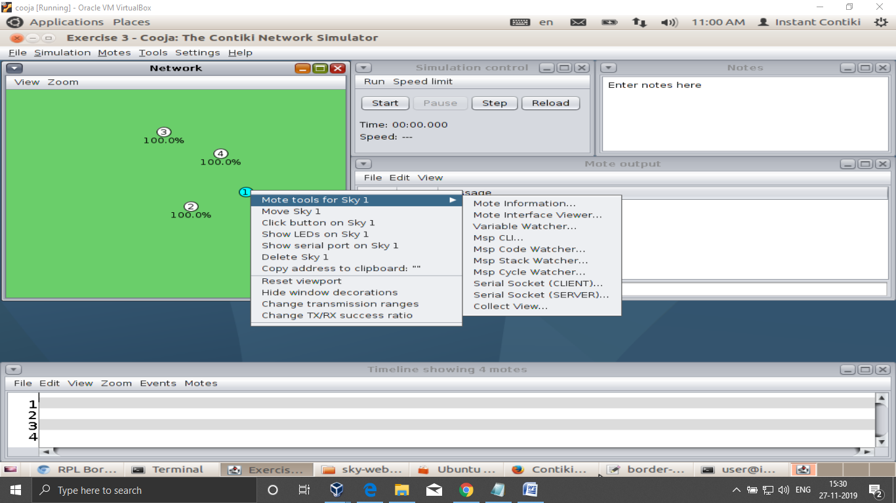

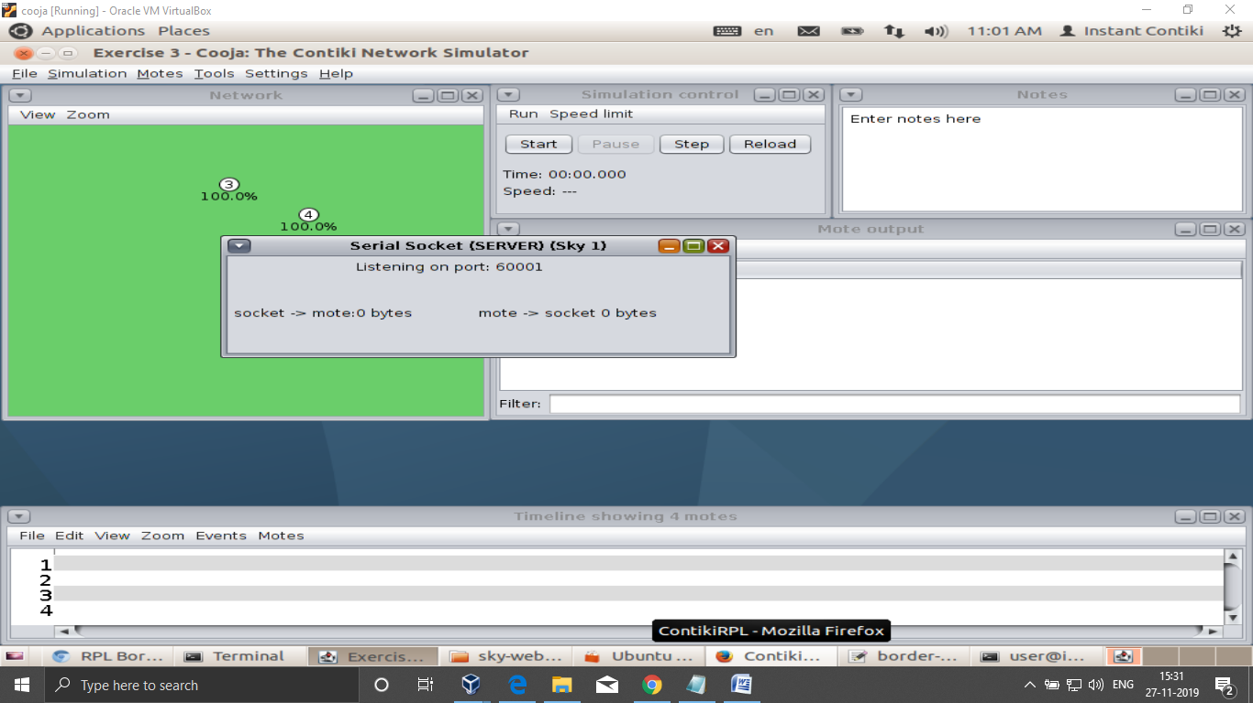

You will see its listening on port 6000x ‘x’ is node number x is 1 in my system

Now linking our system to the router

Step 6 run the simulation

Step 7 in the terminal goto the directory where u have made the tunslip6

Step 8 $ sudo ./tunslip6 –a 127.0.0.1 –p 60001 aaaa::1/64

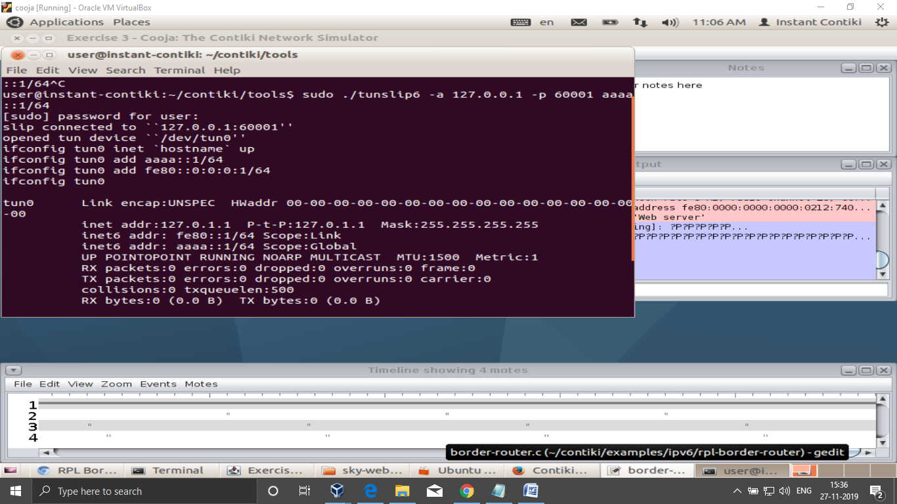

After executing the command the first address in IPv6 adresses is the ipv6 adresse to be noted

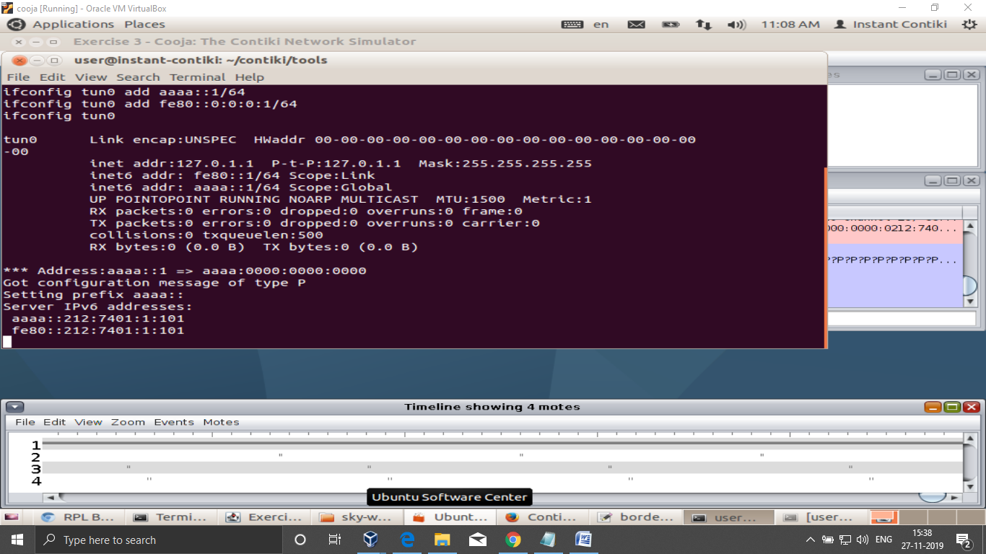

Here it is aaaa::212:7401:1:101

Now go back to simulator you will see the client is connected at 127.0.0.1 our system is connected to the border router server port

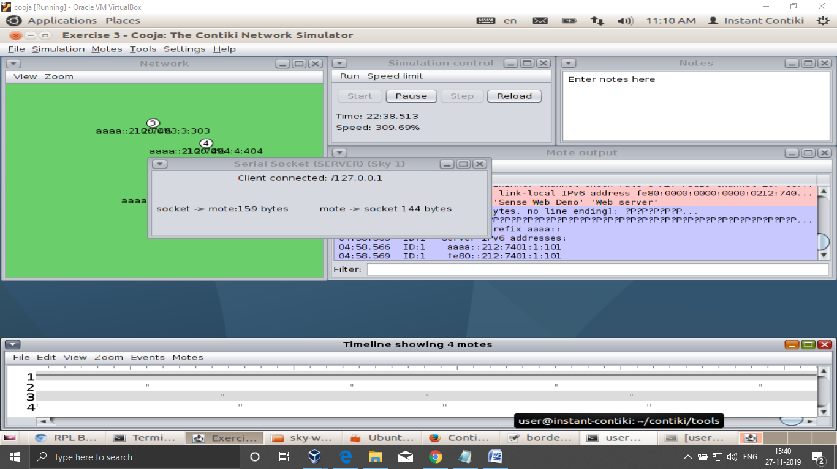

Now got the browser and paste the ipv6 address in square brackets

[aaaa::212:7401:1:101]

Final result

